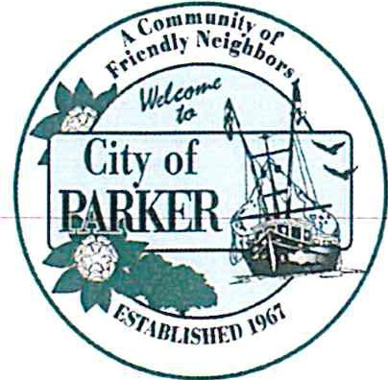
Mayor
Andrew Kelly

City Council
Tonya Barrow, Pro Tern Ron Chaple
Stacie Galbreath April Gibson
CITY OF PARKER

City Hall
1001 West Park Street Phone 850-871-4104

Attorney
Tim Sloan

City Clerk
Kimberly Rega

PUBLIC NOTICE

REGULAR MEETING
THE CITY OF PARKER CITY COUNCIL
September 14, 2023
IMMEDIATELY FOLLOWING THE PUBLIC HEARING

Located at PARKER CITY HALL

NOTE: AT EACH OF ITS REGULAR OR SPECIAL MEETINGS, THE CITY OF PARKER COUNCIL ALSO SITS, AS EX OFFICIO, AS THE CITY OF PARKER COMMUNITY REDEVELOPMENT AGENCY (CRA) AND MAY CONSIDER ITEMS AND TAKE ACTION lN THAT CAPACITY.

AGENDA

CALL TO ORDER - Mayor Kelly
Mayor Kelly calls the meeting to order

ROLL CALL - City Clerk
City Clerk Rega calls roll and all members of the city council are present

INVOCATION/PLEDGE OF ALLEGIANCE – done prior to the regular meeting

ITEMS FROM THE AUDIENCE: (non-agenda items)

Pat Fousek 1344 Stratford

Ms. Fousek questioned the budget placement on the website.

Jami Hinrichs 4612 Sunset Drive

Ms. Hinrichs asked about the CRA fund and how it is that we suddenly have money for the CRA fund when we haven’t had money for years.

Jeanette Howard 1123 E Park Street

Ms. Howard inquired as to whether the ad valorem had anything to do with receiving CRA money.

REGULAR AGENDA
- Opening bid for water system improvements - Anchor Engineering

Mr. Summerlin presented the bids for the SRF water project.

Mr. Sloan asked for clarification as to the process.

The first bid is from CBC Construction

Bid is 6,436,635.00 Bid alternate is 32,988.00

The second bid is from Mainline Construction

Bid is 7,998,673.25 Bid alternate is 44,750.00

The third bid is from Marshall Bothers

Bid is 8,634,550.00 Bid alternate is 33,400.00

The fourth bid is from North Florida Construction

Bid is 12,902,700.00 Bid alternate is 8,000.00

The fifth bid is from Royal American

Bid is 6,144,264.00 Bid alternate is 5,000.00

Mr. Summerlin states that he will return these bids to the engineer for review and after review, the engineer will make their recommendation.

ANNOUNCEMENTS

Mr. Chaple stated that the city is going to have a fun day on November 11 after the parade in Callaway.
No other announcements were made.

  - Audience input for agenda item #1
None provided

ADJOURNMENT
Mayor Kelly adjourns the meeting
If a person decides to appeal any decision made by the city council with respect to any matter considered at the meeting, if an appeal is available, such person will need a record of the proceeding and such person may need to ensure that a verbatim record of the proceeding is made, which record includes the testimony and evidence upon which the appeal is to be made.

Any person requiring special accommodation at this meeting because of a disability or physical impairment should contact the City Clerk at I 00 I West Park Street, Parker, Florida 32404: or by phone at (850) 871-4104. If you are hearing or speech impaired and you have TDD equipment, you may contact the City Clerk using the Florida Dual Party System, which can be reached at 1-800-955-8770 (Voice) or 1-800-955-8771 (TDD).

ALL INTERESTED PERSONS DESIRING TO BE HEARD ON THE AFORESAID agenda are invited to be present at the meeting.

_________________________
Kimberly Rega, City Clerk

